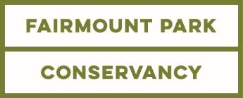

PRESS CONTACTS:
Cari Feiler Bender
610-416-1216, cari@reliefcomm.com
Sharene Azimi
646-784-5547, sharene@missioncomms.com

“A VERY PHILLY CHRISTMAS” CELEBRATED IN FAIRMOUNT PARK HISTORIC HOUSES THIS HOLIDAY SEASON
Four Days of Entertainment, Elaborate Decorations From Local Garden Clubs, A Cheese Sculpture of The Flyers’ Gritty Mascot, And The Debut of
The Ice Bar at Lemon Hill Mansion

PHILADELPHIA – November 8, 2018 – Five of Fairmount Park's historic houses celebrate their 47th year of delighting visitors this December with “A Very Philly Christmas,” featuring holiday-themed tours and special programs at Cedar Grove, Laurel Hill Mansion, Lemon Hill Mansion, Historic Strawberry Mansion, and Woodford inspired by one of our nation’s most historic and dynamic cities. The Historic Houses of Fairmount Park are some of the best-preserved examples of 18th and 19th century early American architecture, all located in one of the country’s most beautiful urban parks. Promotion and programming for the historic houses are supported through a partnership between Philadelphia Parks & Recreation, Fairmount Park Conservancy and various stewardship groups. Proceeds from the events support the ongoing stewardship, maintenance and promotion of these treasures.

Talented local garden clubs will decorate the five mansions in a “very Philly” way, including “A Very Philly Fun Christmas” at Laurel Hill Mansion—celebrating Philadelphia’s heritage as the original home of American carousel-making with replicas of carousel animals on a 12-foot Christmas tree—and “A Very Storied Christmas” at Historic Strawberry Mansion featuring decorations inspired by Philadelphia's Free Library and classic holiday stories.

In the spirit of the “very Philly” theme, the historic houses will host four days of special events showcasing what makes Philadelphia a very special place: its music, food, neighbors, and families.
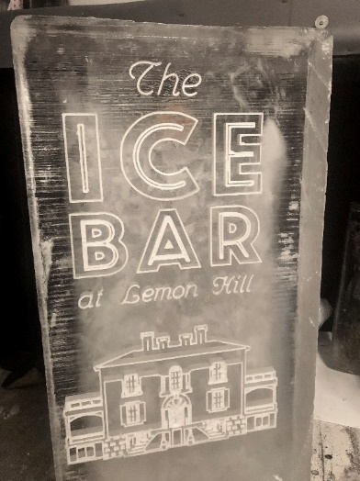
New this year: For six days only, the Ice Bar at Lemon Hill Mansion will serve food and drinks amid ice art from Ice Sculpture Philly that will sparkle thanks to the efforts of lighting designer extraordinaire Drew Billiau. Seating, fire pits, and DJ music will make this a unique place to enjoy the holiday spirit. “Chill out” at the first ever Ice Bar at Lemon Hill Mansion, opening Friday, November 30 on the grounds of this beautiful historical home in Fairmount Park. Visitors will enjoy ice art from Ice Philly Sculpture, including a bar carved from ice and an ice lemon tree with real lemons, and exterior lighting design from Drew Billiau, who has worked with Ballet X and Opera Philadelphia. Beverages will be available from Original XIII Ciderworks and St. Benjamin Brewing Company, and a rotating line-up of food trucks, cozy fire pits, and nightly DJ entertainment will complete the experience. Admission: $5 suggested donation.
Sedgeley Drive and Lemon Hill Drive
Friday, 11/30, 5-9pm; Saturday 12/1 & Sunday 12/2, 12-9pm
Friday, 12/7, 5-9pm, Saturday 12/8 & Sunday 12/9, 12-9pm

On Sunday, December 2, Philadelphians young and old will be sure to love the cheese sculpture of the Philadelphia Flyers’ new mascot, Gritty, from JVMP Food Sculpture in Conshohocken courtesy of Cabot Cheese in celebration of Family Day at Lemon Hill Mansion. Come get a selfie with Cheese Gritty.

DETAILS AND SCHEDULES
“A Very Philly Christmas” Programming
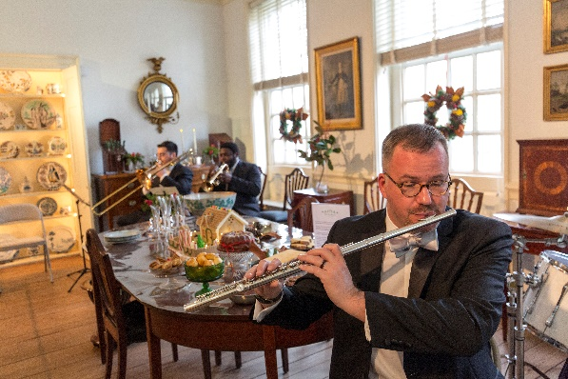
Special programming for “A Very Philly Christmas,” including the Ice Bar at Lemon Hill, takes place on the weekends of November 30 - December 2 and December 7 – December 9 are listed below. All programs take place at each of the five houses unless otherwise noted.
Black Pearl Chamber Orchestra at Sounds of the Season 2017/Fairmount Park Conservancy

Sounds of the Season: Saturday, December 1
Join Fairmount Park Conservancy as the historic houses showcase some of the best classical, jazz, gospel, and Latin music in Philadelphia with Clef Club of Jazz and the Performing Arts, the Black Pearl Chamber Orchestra, Opera Philadelphia, Minas Brazilian Music, Joanna Pascale, and the New Covenant Church Sanctuary Choir. Presented by WRTI 90.1FM. Price: All-Houses Day Pass $30

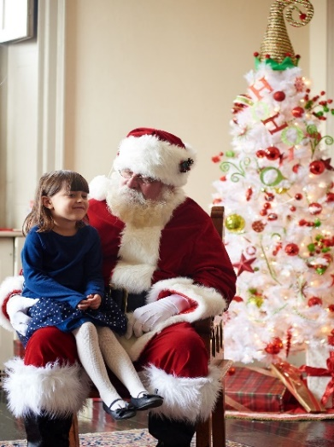
Santa at Family Day 2017/Fairmount Park Conservancy

Family Day at Lemon Hill Mansion, Sunday, December 2
Bring your favorite young ones for a day of fun kid-friendly activities including a picture-perfect visit with Santa and featuring a cheese sculpture of the Philadelphia Flyers’ mascot, Gritty, courtesy of Cabot Cheese. Free admission for all children under 12.
Price: $10 admission for Lemon Hill Mansion, All-Houses Day Pass $25

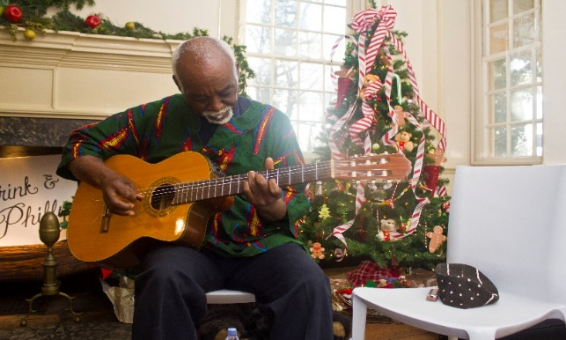
Neighbor’s Day: Saturday, December 8
Joe Becton at Neighbor’s Day 2016/Fairmount Park Conservancy
Stop by the houses as we celebrate the many talents of our nearby neighbors Enjoy wonderful local music and food.
Price: All-Houses Day Pass $30

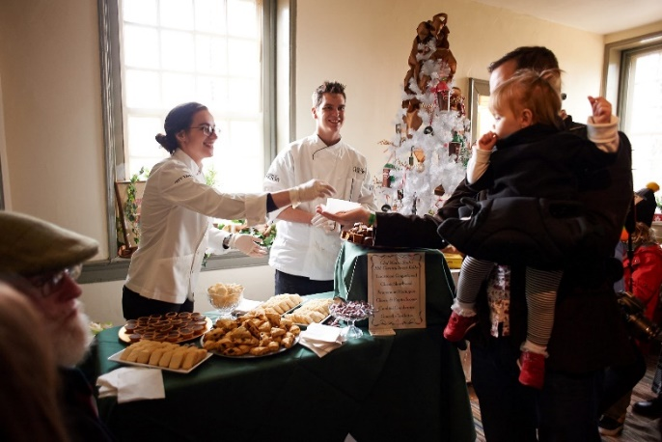
Flavors of the Season: Sunday, December 9
City Tavern Staff at Flavors of the Season 2016/Fairmount Park Conservancy
Bring an appetite and culinary curiosity to the houses to sample treats and enjoy food demonstrations from some of the best local food purveyors such as Shane Confectionery, City Tavern, Essen Bakery, Birchtree Catering, Cabot Cheese, John and Kira’s Chocolates and a special appearance by Walter Staib from PBS’ “A Taste of History.”
Price: All-Houses Day Pass $30

House Tours
In addition to the special programming listed above, visitors can stop by the historic houses throughout December to enjoy this festive time of year. Tickets are $8 per house. Day passes to visit all 5 houses available for as low as $25. Dates and times vary. The Fairmount Park Historic Houses are located at:
Cedar Grove, 1 Cedar Grove Dr.
Laurel Hill Mansion, 7201 N Randolph Dr
Lemon Hill Mansion, Sedgeley Dr. & Lemon Hill Dr.
Historic Strawberry Mansion, 2450 Strawberry Mansion Dr.
Woodford Mansion, 3400 West Dauphin Dr.

For full schedules and to purchase tickets in advance, see: holidaysinthepark.com

Transportation
Limited parking is available at each historic house. The “Holiday Houses Loop” powered by PHLASH will offer house to house transportation throughout December. Some additional cost may apply.

Fairmount Park Conservancy exists to champion Philadelphia’s parks. We lead capital projects and historic preservation efforts, foster neighborhood park stewardship, attract and leverage investments, and develop innovative programs throughout the 10,200 acres that include Fairmount Park and more than 100 neighborhood parks around the city. For more information, please visit myphillypark.org, join us at facebook.com/fairmountparkconservancy, and follow us on Instagram and Twitter @myphillypark.

Philadelphia Parks & Recreation (PPR) advances the prosperity of the city and the progress of her people through intentional and sustained stewardship of nearly 10,200 acres of public land and waterways as well as through hundreds of safe, stimulating recreation, environmental and cultural centers. PPR promotes the well-being and growth of the city’s residents by connecting them to the natural world around them, to each other and to fun, physical and social opportunities. PPR is responsible for the upkeep of historically significant Philadelphia events and specialty venues, and works collaboratively with communities and organizations in leading capital projects and the introduction of inventive programming. To learn more about Philadelphia Parks & Recreation, visit us at www.phila.gov/parksandrec, and follow @philaparkandrec on Facebook, Twitter, Instagram, or Tumblr.

For high-resolution images for media use, please visit the online press room at http://bit.ly/ConservancyPressKit.
###

