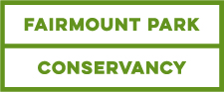

MEDIA ADVISORY

“A VERY PHILLY CHRISTMAS” DEBUTS AT HISTORIC HOUSES OF FAIRMOUNT PARK
Press Preview December 1
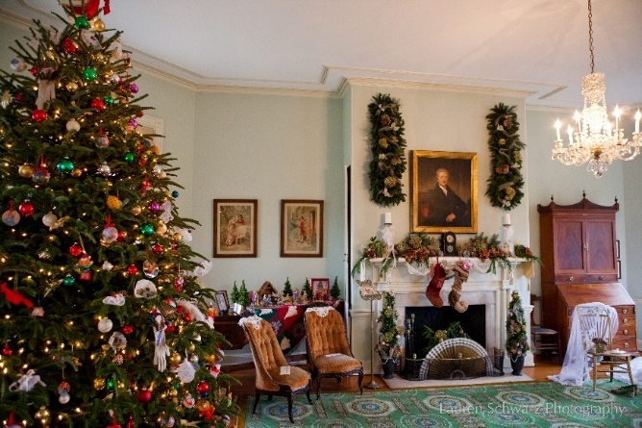
The Historic Houses of Fairmount Park have a popular longtime tradition of decorating for the holidays and entertaining visitors; this season, four days of programming will be added to showcase what makes Philadelphia a very special place: great music, delicious food, families, and friendly neighbors. “Christmas in Fairmount Park” celebrates its 45th year of delighting visitors with this year’s theme, “A Very Philly Christmas.” Presented by Fairmount Park Conservancy and Philadelphia Parks & Recreation, this holiday tradition will feature six of the park’s treasured historic houses – Cedar Grove, Laurel Hill Mansion, Lemon Hill Mansion, Mount Pleasant, Strawberry Mansion, and Woodford – each decked out in the season’s finest and offering special events on the weekends of December 3-4 and December 10-11. A seasonal route of PHLASH will help visitors travel into and through Fairmount Park to view the historic houses.

WHAT: Preview of “Christmas in Fairmount Park” featuring “A Very Philly Christmas”
WHEN: Thursday, December 1, 11 am
WHERE: Lemon Hill Mansion, Sedgeley & Lemon Hill Drives, Philadelphia, PA 19130

WHO: Rick Magder, Executive Director, Fairmount Park Conservancy
Aparna Palantino, Deputy Commissioner, Philadelphia Parks & Recreation
James J. Cuorato, President & CEO, Independence Visitor Center Corporation
Ed Miller, Historic Houses Coordinator, Fairmount Park Conservancy
Students from The City School in the Fairmount/Brewerytown neighborhood

FEATURING:
Quiet Storm, authentic Philly doo-wop group
Giambri’s Quality Sweets, artisanal candy canes
Local students placing the final touches on the Lemon Hill Christmas trees

PROJECT DETAILS:
Lemon Hill Mansion will be finalizing decorations for the “Christmas in Fairmount Park” with décor celebrating "Philadelphia's Winter Traditions" including:
- "Fairmount Park: A Winter Wonderland” – an installation celebrating the woodland retreat where Philadelphians have enjoyed the snowy pastimes of skating, sleighing, sledding, and tobogganing for more than 150 years.
- “Kris Kringle’s Headquarters” will honor the first department store Santa, hired by James Parkinson of Philadelphia to entertain children (and attract their parents) in 1841 at his confectionery store on Chestnut Street.
- Lemon Hill's famed Oval Room will feature three decorated trees inspired by Mummers’ costumes on loan from the Mummers Museum. In addition, the snowflake screens on display will incorporate snowflakes made by children at local schools The City School and St. Francis Xavier School as well as at the East Passyunk Community Center at 11th and Mifflin Streets.
- The upper floor will feature a “Made in Philly” exhibit highlighting Christmas decorations manufactured in the city from the 1880s through the present. Visitors will also find a tree inspired by Santa, who will make an appearance at Lemon Hill on Family Day (Sunday, December 4).

From December 1-31, “Christmas in Fairmount Park” features decorations and house tours at Cedar Grove, Laurel Hill Mansion, Lemon Hill Mansion, Mount Pleasant, Strawberry Mansion, and Woodford.

Programming for “A Very Philly Christmas” takes place at the participating houses on four days from 10 am - 4 pm:
- Sounds of the Season: Saturday, December 3: Enjoy live performances celebrating the musical diversity of the city, sponsored by WRTI-FM.
- Family Day: Sunday, December 4: Bring the kids for a full day of holiday entertainment and activities. Children 12 and under admitted free!
- Neighbor’s Day: Saturday, December 10: Check out the many talents of the neighbors who live near and around Fairmount Park.
- Flavors of the Season: Sunday, December 11: Sample holiday delights from local food superstars and taste the latest from Chef Walter Staib of City Tavern.
For the full schedule and ticketing, visit: holidaysinthepark.com

ABOUT THE PROJECT:
The Historic Houses of Fairmount Park are some of the best-preserved examples of 18th and 19th century early American architecture, all located in one of the country’s most beautiful urban parks. Six of these houses, known as the Park Charms, operate throughout the year as historic house museums and welcome the public to visit these architectural and cultural gems. Promotion and programming for the historic houses are supported through a partnership between the City of Philadelphia Parks and Recreation Department, Fairmount Park Conservancy, and various stewardship groups. Proceeds from the events support the ongoing stewardship, maintenance and promotion of these treasures.

Fairmount Park Conservancy exists to champion Philadelphia’s parks. Our mission is to work as a collaborative partner to lead and support efforts that preserve and improve the parks and recreation system in order to enhance the quality of life and stimulate economic development of the Greater Philadelphia Region. We fulfill our mission by leading capital projects and historic preservation efforts, fostering neighborhood park stewardship, attracting and leveraging resources for the parks, and developing innovative programs throughout the 10,200 acres that include Fairmount Park and more than 100 neighborhood parks around the city. The Fairmount Park system is one of the largest urban park systems in the world and includes some of the region’s most famous attractions. For more information, please visit myphillypark.org, join us at facebook.com/fairmountparkconservancy, and follow us on Instagram and Twitter @myphillypark.

Philadelphia Parks & Recreation advances the prosperity of the city and the progress of her people through intentional and sustained stewardship of public land and waterways as well as through safe, stimulating recreation, environmental and cultural centers. PPR helps Philadelphia’s children and other residents grow by connecting them to the natural world, to each other, and to fun, physical and social opportunities. For more information, find Philadelphia Parks & Recreation online at www.phila.gov/parksandrecreation and follow @philaparkandrec on social media:

###
PRESS CONTACTS:
Cari Feiler Bender (on behalf of Fairmount Park Conservancy)
(610) 416-1216, cari@reliefcomm.com
Sharene Azimi (on behalf of Fairmount Park Conservancy)
(646) 784-5547, sharene@missioncomms.com
Alain Joinville, Philadelphia Parks & Recreation
(267) 886-3032, alain.joinville@phila.gov

